Keeping Children Safe In Education (KCSIE) September 2024 Briefing

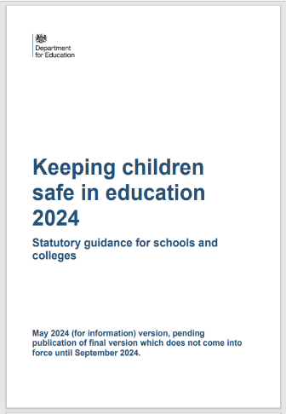
Keeping Children Safe in Education is Statutory guidance. For the purposes of this guidance, children includes everyone under the age of 18. Everyone working directly with children are expected to read at least part 1 of KCSIE and Annex B.

Brief Summary Of Changes
There are relatively few changes this year (2024) but of particular importance is an amendment to the definition of ‘safeguarding and promoting the welfare of children.’ The definition of safeguarding has been amended to reflect the changes made in Working Together to Safeguard Children (2023). Paragraph 3 now states “Safeguarding and promoting the welfare of children is defined for the purposes of this guidance as:
• providing help and support to meet the needs of children as soon as problems emerge
• protecting children from maltreatment, whether that is within or outside the home, including online
• preventing the impairment of children’s mental and physical health or development
• ensuring that children grow up in circumstances consistent with the provision of safe and effective care
• taking action to enable all children to have the best outcomes.

Early Help
- Paragraph 18 has been amended to add that everyone should be alert to the potential need for Early Help for pupils who have “experienced multiple suspensions, [are] at risk of being permanently excluded from schools, colleges and in Alternative Provision or a Pupil Referral Unit.”
- In Part Five where options to manage reports of child-on-child sexual violence and/or sexual harassment are discussed, paragraph 497 has been amended to include the importance of Early Help at any stage in a child’s life. It states, “Early Help is support for children of all ages that improves a family’s resilience and outcomes or reduces the chance of a problem getting worse.”
If you are concerned about a family please speak to your Area Advisor. Early Help can include, for example, an Area Advisor speaking to a family and encouraging them to see a doctor or signposting them to an agency who might be able to help them.

Children and the court system
In Annex B, links to two age-appropriate guides have been included to support children who are required to give evidence in court. Worth noting in case you work with a young person in this position.

Preventing radicalisation
In Annex B, a disclaimer has been added to outline that this section is still under review following the new definition of extremism released on 14th March 2024. Additional wording changes have been made to this section alongside clarification that “although there is no single way of identifying whether a child is likely to be susceptible to radicalisation into terrorism, there are factors that may indicate concern.”

Wording and minor definition changes
Several wording and minor definition changes occur in KCSIE 2024, including:
• Headings have been amended across KCSIE to reflect that pupils may experience “abuse, neglect and exploitation” rather than solely “abuse and neglect”. (Paragraph 19)
• The definition of abuse has been expanded slightly to emphasise that witnessing ill treatment of others is harmful to children. The paragraph makes references to the relevance of this in all forms of domestic abuse, including where children “see, hear or experience its effects”. (Paragraph 24)
• In the section called ‘safeguarding issues’ (which outlines the awareness of safeguarding issues that staff should have), the wording about absence has been changed. The term “deliberately missing education” has been replaced with “unexplainable and/or persistent absences from education”. (Paragraph 31)

Your Home-School Tutoring Area Advisor is the first point of contact for any member of the school staff who has a concern about the safety and well-being of a pupil. They should be available to discuss safeguarding concerns. If in exceptional circumstances, the Area Advisor is not available, this should not delay appropriate action being taken. Tutors should consider speaking to local children’s social care or phoning the police if a child is at risk of immediate harm. In these circumstances, any action taken should be shared with the Area Advisor as soon as is practically possible.

This briefing was based on: NSPCC Caspar Briefing: Keeping Children Safe in Education 2024 Summary of changes (https://learning.nspcc.org.uk)

Home-School Tutoring UK Ltd September 2024.

